Research on Kidney Tumor Detection and Analysis

Academic Group Research Presentation  
Prepared for [Introduction to Data Science]

*Group Members:  
1. Muhammad Qasim Ashfaq  
2. Safa Khurshid  
3. Nazim Raza  
4. Khateeba Zainab  
5. Manahal Nadar*

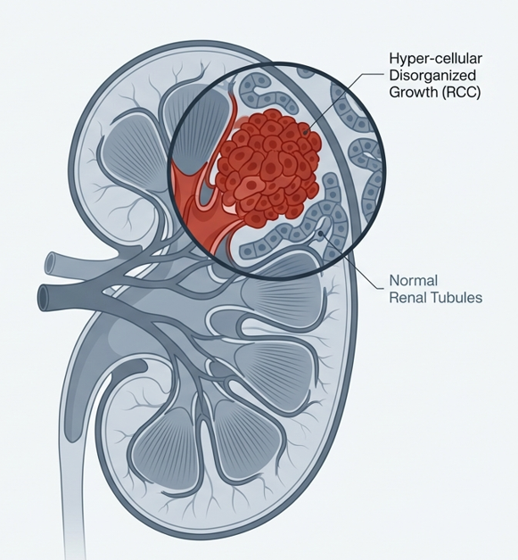

Table of Contents

Kidney cancer, also known as renal cancer, is a group of cancers that starts in the kidney. Kidney tumors, or renal masses, are abnormal growths in the kidney. Symptoms may include blood in the urine, a lump in the abdomen, or back pain. Fever, weight loss, and tiredness may also occur. Complications can include spread to the lungs or brain. 3

Types of Kidney Tumors 3

1)Malignant Tumors (They Spread from one part to the other) 3

🡪Renal Cell Carcinoma (RCC): 3

Statistics: 3

🡪Transitional Cell Carcinoma: 3

Statistics: 4

🡪Wilms Tumor (Nephroblastoma): 4

2) Benign Tumors (Peaceful Tumors but may become Malignant afterwards) 5

🡪Renal Adenoma: 5

🡪Angiomyolipoma (AML): 5

🡪Oncocytoma: 5

Primary Causes and Risk Factors: 7

Common Symptoms: 7

Testing for a Kidney Cancer Diagnosis 8

🡪Physical exam to check your overall health: 8

🡪Complete medical and family history 8

Blood tests: 9

🡪Urinalysis: 9

🡪Computed Tomography (CT) Scan: 9

🡪Magnetic Resonance Imaging (MRI) 10

🡪Bone scan: 10

11

🡪Chest x-ray: 11

🡪Biopsy: 11

AI and Machine Learning Platforms: 12

Radiomics Platforms: 12

Liquid Biopsy Platforms: 12

Introduction to Kidney Tumor

# Kidney cancer, also known as renal cancer, is a group of cancers that starts in the kidney. Kidney tumors, or renal masses, are abnormal growths in the kidney. Symptoms may include blood in the urine, a lump in the abdomen, or back pain. Fever, weight loss, and tiredness may also occur. Complications can include spread to the lungs or brain.

# Types of Kidney Tumors

Kidney tumors are broadly categorized into malignant (cancerous) and benign (non-cancerous).

# 1)Malignant Tumors (They Spread from one part to the other)

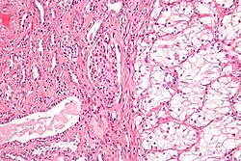🡪Renal Cell Carcinoma (RCC):

The most common form of adult kidney cancer (approx. 85-90%). Renal cell carcinoma (RCC) is a kidney cancer that originates in the lining of the proximal convoluted tubule, a part of the very small tubes in the kidney that transport primary urine.

### Statistics:

RCC is the most common type of kidney cancer in adults, responsible for approximately 90–95% of cases. It is more common in men (with a male-to-female ratio of up to 2:1). It is most commonly diagnosed in the elderly (especially in people over 75 years of age).

## undefined🡪Transitional Cell Carcinoma:

Transitional cell carcinoma is a type of cancer that arises from the transitional epithelium, a tissue lining the inner surface of these hollow organs. It typically occurs in the urothelium of the urinary system; in that case, it is also called urothelial carcinoma. It is the most common type of bladder cancer and cancer of the ureter, urethra, and urachus. Symptoms of urothelial carcinoma in the bladder include hematuria (blood in the urine). Diagnosis includes urine analysis and imaging of the urinary tract (cystoscopy).

### Statistics:

It accounts for 95% of bladder cancer cases and bladder cancer is in the top 10 most common malignancy disease in the world and is associated with approximately 200,000 deaths per year in the United States alone

🡪Wilms Tumor (Nephroblastoma):The most common kidney cancer in children.

|  |  |
| --- | --- |
| **Other names:** | Wilms' tumor Nephroblastoma |
|  | |
| High magnification micrograph showing the three elements of Wilms' tumor. H&E stain. | |
| **Usual onset** | 1–4 years old |
| **Treatment** | Nephrectomy Radiotherapy |
| **Prognosis** | ~90% of children are cured |
| **Frequency** | ~500 new diagnoses per year (United States) |
| **Named after** | Max Wilms |

# 2) Benign Tumors (Peaceful Tumors but may become Malignant afterwards)

* 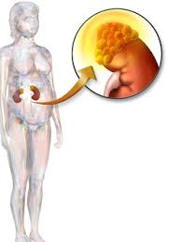A benign tumor is a mass of cells (tumor) that does not invade neighboring tissue or metastasize (spread throughout the body). Compared to malignant (cancerous) tumors, benign tumors generally have a slower growth rate.

## 🡪Renal Adenoma:

Renal adenomas are common, typically small, benign (noncancerous) tumors arising from the renal tubular epithelium. Often found incidentally, they appear as pale yellow-gray nodules in the kidney cortex. Small, slow-growing tumors.

## 🡪Angiomyolipoma (AML):

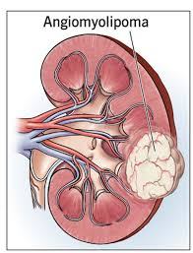Angiomyolipoma’s are the most common benign tumor of the kidney. Although regarded as benign, angiomyolipoma may grow such that kidney function is impaired.Common benign tumors made of fat, blood vessels, and muscle tissue.

## 🡪Oncocytoma:

Frequently detected benign tumors that can sometimes mimic RCC on imaging. An oncocytoma is a tumor made up of oncocytes, epithelial cells characterized by an excessive number of mitochondria, resulting in an abundant acidophilic, granular cytoplasm. The cells and the tumor that they compose are often benign but sometimes may be premalignant or malignant.



STAGES

Causes, Risk Factors, and Symptoms

# Primary Causes and Risk Factors:

* Tobacco use (Smoking increases risk significantly).
* Obesity and hypertension (High blood pressure).
* Family history and genetic syndromes (e.g., von Hippel-Lindau disease).
* 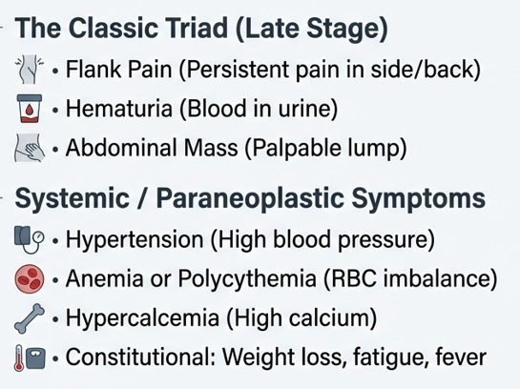Long-term dialysis treatment.
* Occupational exposure to chemicals like cadmium and trichloroethylene.

# Common Symptoms:

Early-stage kidney tumors are often 'silent' (asymptomatic). As they grow, they may cause:

* Hematuria (Blood in the urine).
* Low back pain on one side (not caused by injury).
* A mass or lump on the side or lower back.
* Fatigue and unexplained weight loss.
* Persistent fever not caused by an infection.

Diagnosis and Staging

# Testing for a Kidney Cancer Diagnosis

Doctors can do different tests to find out how much cancer is in your body. These tests can also help you and your doctor create your treatment plan. Your primary care doctor may have already done some of these tests for your initial diagnosis. However, a kidney cancer specialist may need to redo some or all of these tests.

If you have a kidney tumor, a kidney cancer specialist or team of specialists will do tests to find out:

* The size of the tumor
* If the tumor is cancerous
* If any cancer cells have spread to other parts of your body
* What treatment options are available

Tests or exams may include:

## 🡪Physical exam to check your overall health:

This could include checking vital signs like:

* Blood pressure
* Temperature
* Weight
* Pulse (heart beats)

## 🡪Complete medical and family history

Your healthcare team will ask you about medicines you take, any other health conditions, and results of your health tests. They will want to know if any family members have had kidney cancer or other diseases.

## Blood tests:

Your team will take samples of your blood to check how well your kidneys are working and your overall health. Some blood tests include:

* **Complete Blood Count (CBC) test** – this measures the number of cells in the blood such as red blood cells, white blood cells, and platelets.
* **Blood chemistry tests** – these look at how well your liver and kidneys are working, and electrolytes like sodium and potassium.

## 🡪Urinalysis:

A test of your urine (pee) that looks for blood, extra proteins, or infection

## 🡪Computed Tomography (CT) Scan:

An imaging test that uses X-rays to create detailed images of certain areas of your body. It helps doctors find cancer. They will scan your abdomen (belly) and pelvis to show your kidneys and nearby areas to see if the cancer has spread.

* 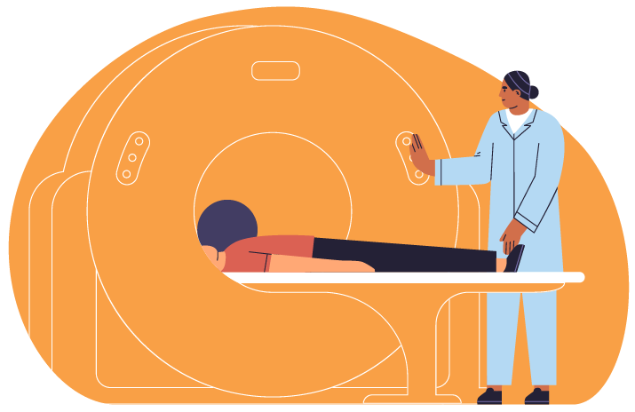Before your scan, you may get contrast (a substance that you take by mouth or get injected into a vein) to improve the quality of the imaging pictures. Tell your doctor if you’ve had any reaction to contrast or iodine in the past

## 🡪Magnetic Resonance Imaging (MRI)

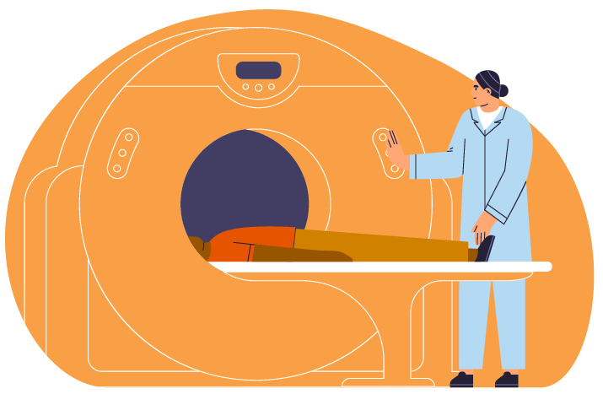An imaging test that uses radio waves and powerful magnets to take pictures of your body. An MRI is used to check if kidney cancer has spread to major blood vessels or the brain.

* During an MRI you will need to lie still in an enclosed space for 15 – 90 minutes. Before your doctor schedules an MRI, tell them if you’re anxious about being in an enclosed space. They may have options to make you more comfortable during the MRI.
* If you have metal in your body, such as a hip replacement or pacemaker, let your doctor know.

## 🡪Bone scan:

An imaging test that can show if the cancer has spread to your bones.

* Before the scan, a small amount of radioactive material is injected into a vein. It takes about 3 hours for the material to enter your blood. Doctors use a special camera to take pictures of the material in your bones.

## 

## 🡪Chest x-ray:

An imaging test to see if the cancer has spread to your lungs. If something shows on the X-ray, your doctor may order a CT scan of your chest for a better look.

## 🡪Biopsy:

A procedure where a doctor removes a small sample of your tumor with a needle. Your team examines the sample to see if it is cancerous.

* A doctor (a urologist, surgeon, interventional radiologist, or another doctor) will insert a long thin needle through your skin into the tumor and remove a small sample.
* A pathologist at a lab will look at the tissue under a microscope to see what the cells look like and make a diagnosis.
* If the cancer has spread, your team may biopsy a sample from other areas of your body.

Based on imaging tests, some patients won’t have a biopsy and will go straight to surgery. Your doctor will decide what is the best way to determine if you have kidney cancer.

Detection Research Across Multiple Platforms

Modern research seeks to automate and improve the accuracy of kidney tumor detection. This involves leveraging diverse technological platforms:

# AI and Machine Learning Platforms:

Convolutional Neural Networks (CNNs) are being deployed on cloud-based platforms (like AWS SageMaker or Google Cloud AI) to segment kidneys and tumors from CT scans. The 'KiTS21' (Kidney Tumor Segmentation) challenge is a leading platform providing datasets for researchers to benchmark their algorithms.

# Radiomics Platforms:

Radiomics involves extracting large amounts of quantitative data from medical images. Software platforms like Pyradiomics enable researchers to identify 'texture' signatures that can distinguish between benign oncocytomas and malignant RCC without invasive biopsies.

# Liquid Biopsy Platforms:

Emerging research focuses on detecting circulating tumor DNA (ctDNA) or microRNA in blood and urine samples. Diagnostic platforms utilizing High-Throughput Sequencing (HTS) are being tested to detect kidney cancer at its molecular stage before it is visible on a scan.

Key Statistics

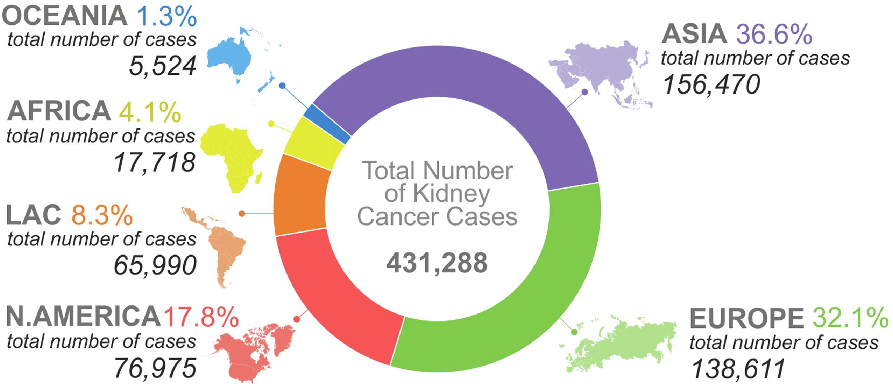

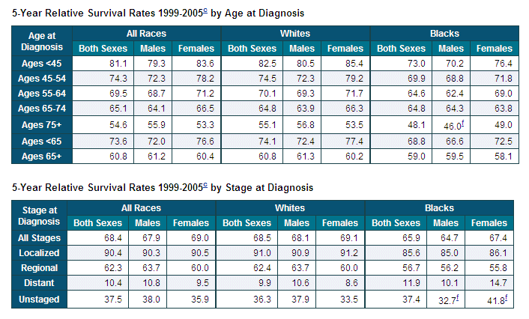

Conclusion

The landscape of kidney tumor detection is shifting from purely symptomatic diagnosis to data-driven, multi-platform screening. While CT scans remain the primary diagnostic tool, the integration of Artificial Intelligence and Radiomics is significantly reducing the rate of unnecessary surgeries for benign masses. For our group presentation, it is concluded that multi-modal data fusion—combining imaging, genetics, and clinical data—represents the future of precision urology.

